Warning Parser is a Python script designed to parse compiler-generated files with the .warn extension and create various statistics with parsed data. It can parse files generated by TASKING, IAR and Cosmic compilers.

Script call example:

Warning_parser.exe -w=S:\Tools\Build_Env\Workspace\Outputs\app\Err\

-s=S:\Components\Application\*\

-l=-1

-o=C:\Scripts\Warning_parser\output

-b=1

-d=13.12.2021

The arguments from the Warning Parser script entry are as follows:

**-w - Path to Err folder to be parsed.** For example: -w=S:\Tools\Build_Env\Workspace\Outputs\app\Err\ ! PAY ATTENTION TO KEEP A "\" CHARACTER AFTER LAST FOLDER FROM PATH. This argument is mandatory.

**-s - Path to Components folder.** This argument is used to find source file of generated warning file. For example: -s=S:\Components\Application\*\ ! PAY ATTENTION TO ADD AT FINAL PATH "\*\" DIRECTORY. This argument is mandatory. This argument can be called several times in the same call, so this script supports multiple component paths.

**-l - Depth of source code directory.** Generally, set it to -1. This argument is mandatory. This argument is used to find the component name in the Components folder. This argument can be called several times in the same call, so this script supports multiple path depths.

**-o - Ouput path** to a folder where to generate files. For example: -o=C:\Scripts \Warning_parser\output. This argument is mandatory.

**-b - Build Number**. This argument is optional.

**-d - Build Date**. This argument is optional.

After running the script (using the file with the .bat extension), in the output path there will be 4 generated files (if all arguments are given) or only 2 generated files (if not given as arguments Build Number and Build Date ).

Output Description:

**global_warning_stats.csv** - This file will contain a global statistic data ( a total number of founded warnings per run ). If this file exists already, it will be updated with new values. If this file has not being found in Output folder, it will be created.

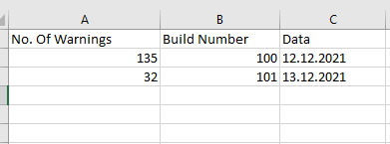

**module_warning_stats.csv** - This file will be generated every time this script runs. It will contain warnings found in .warn files per every component.

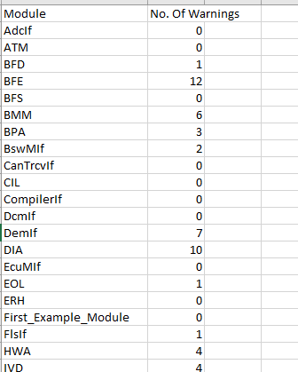

**Compiler_Warnings_per_Module.png** - This file will be generated every time this script runs. This file will be generated based on module_warning_stats.csv.

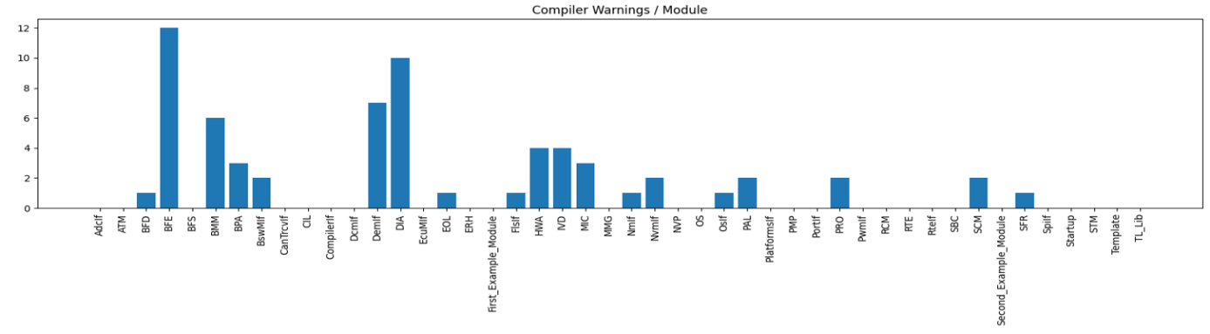

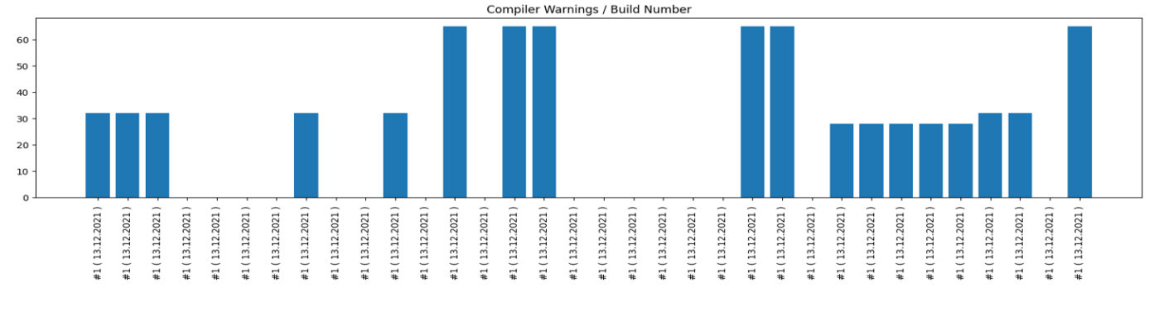**Compiler_Warnings_per_Build_Number.png** - This file will be generated every time this script runs. This file will be generated based on global_warning_stats.csv.

Script notes:

1. If arguments Build Number and Build Date are not given to script, no .png graphics will be generated. Thus, in order to generate graphics, you must give a date and a build number.

2. If you files are compiled from S: drive ( a make-all release command from S: drive ) then you should give arguments to Warning Parser script from S: drive. If you compile files from C: drive, then write arguments from C: drive. Otherwise, components name cannot be found.

3. This script goal's was to be used, first of all, with Jenkins Server. So, this script was tested succesfully on Jenkins server on AUDI_TR6_Release Project and JLR_MLA Project.